Doctor Honoris Causa
For: Prof. dr. Jacques J.M. van Dongen
From: Charles University Prague (Universitas Carolina Pragensis; founded 7 April 1348), Prague, CZ
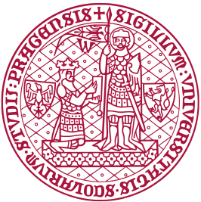
Charles University of Prague (Rector: Prof. dr. Milena Králíčková; Promotor: Prof. dr. Jan Trka) has awarded an Honorary Doctorate (Doctor Honoris Causa) to Prof. Jacques J.M. van Dongen, MD, PhD for the successful initiation and long-term coordination of three large European Consortia in the field of innovative molecular and cellular diagnostics in Immunology and Hematology. The three consortia, EuroFlow, EuroClonality and EuroMRD, have originally been supported by EU-consortium grants (Concerted Actions), and have obtained long-term sustainability (15 to 25 years) based on innovative immunodiagnostic concepts, which have been patented (12 granted patents and 6 patents pending). The license revenues (mainly royalties) of these collectively-owned patents are solely used for continuation of the European collaborations, supported by the ESLHO Foundation (www.ESLHO.org). All novel immunodiagnostic tests of the three consortia are being developed and standardized for direct application in diagnostic patient care for patients with hematological malignancies, patients with suspicion of an immunodeficiency, patients with inflammatory diseases or for evaluation of immune responses in infectious diseases or upon vaccination. In the meantime, many of these diagnostic tests are not only used in Europe, but have become world-wide standards. The immunodiagnostic CLIP laboratories of the Second Medical Faculty at Charles University belong to the ~65 European laboratories, coordinated by Van Dongen.
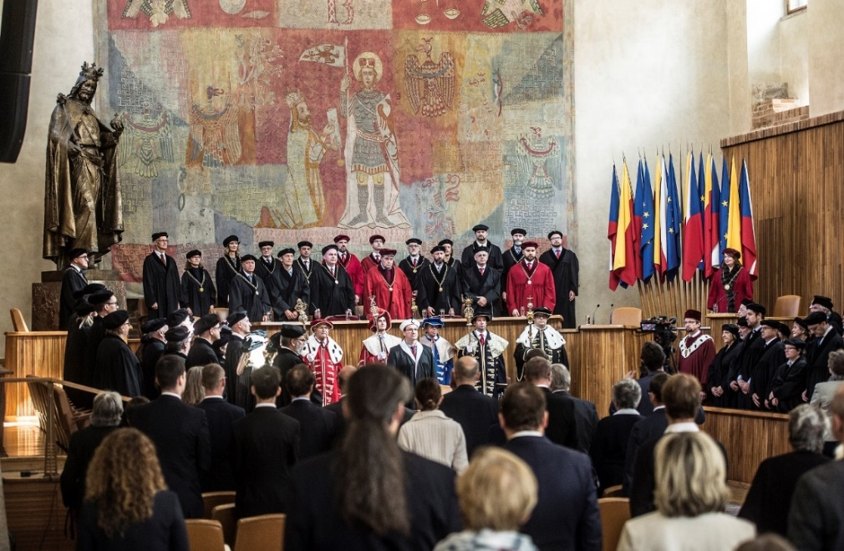
Opening of the Honorary Doctorate Ceremony by the Rector, Vice-Rectors, Deans and professors of Charles University in the Carolinum, the original university building, dating from the 14th century.
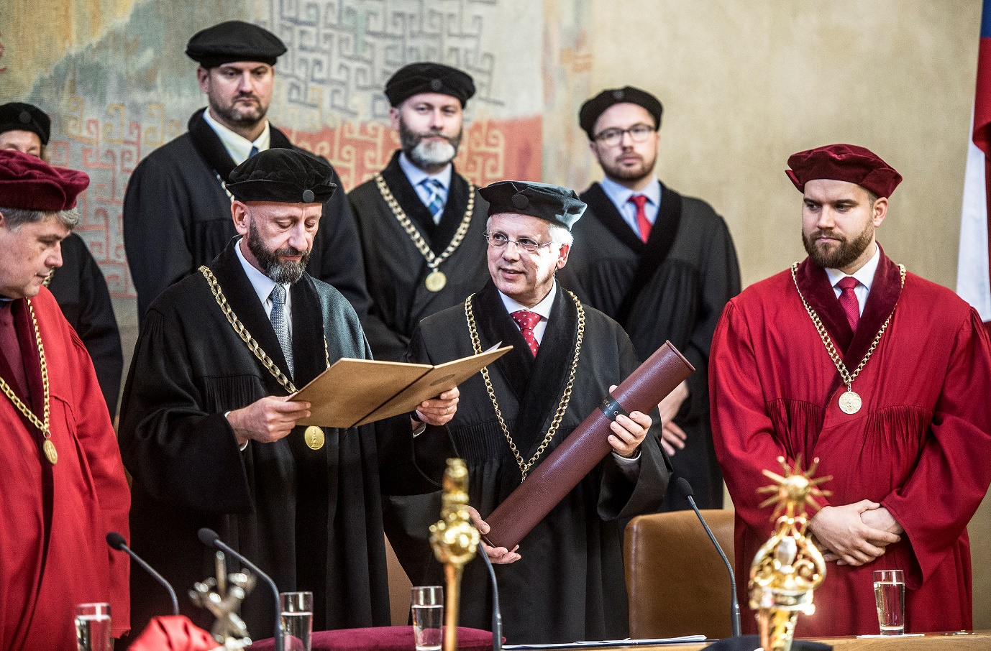
Laudatio and presentation of the diploma and golden Charles University-medal by Professor Jan Trka on the occasion of the Honorary Doctorate (Doctor Honoris Causa; DrHc).

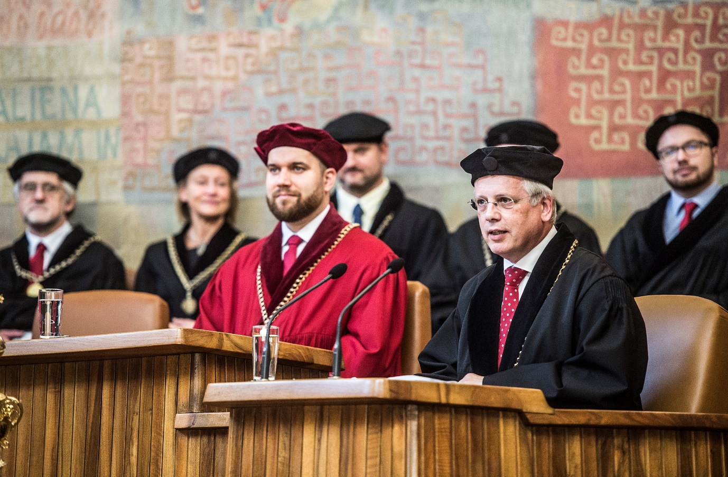
Honorary Doctor’s Speech by Prof. dr. Jacques J.M. van Dongen, MD, PhD
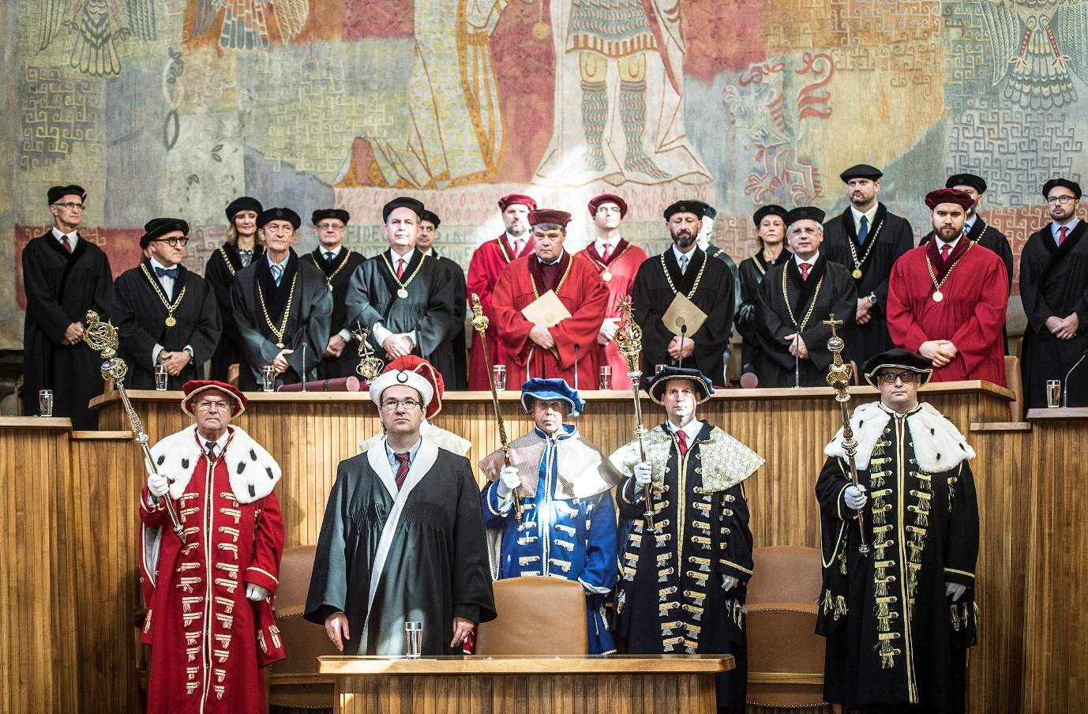
Closure the Honorary Doctorate Ceremony in the Carolinum of Charles University
(original university building, dating from the 14th century)

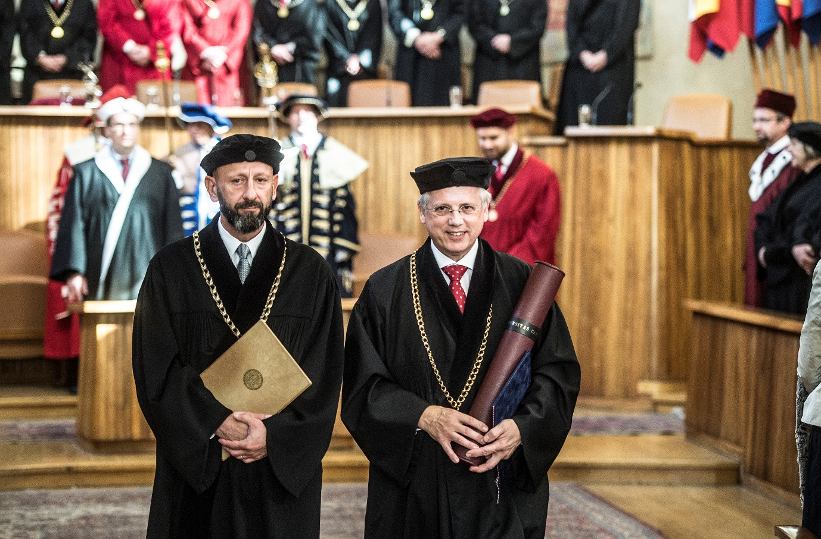
Cortège at closure of the Honorary Doctorate Ceremony in the Carolinum of Charles University.
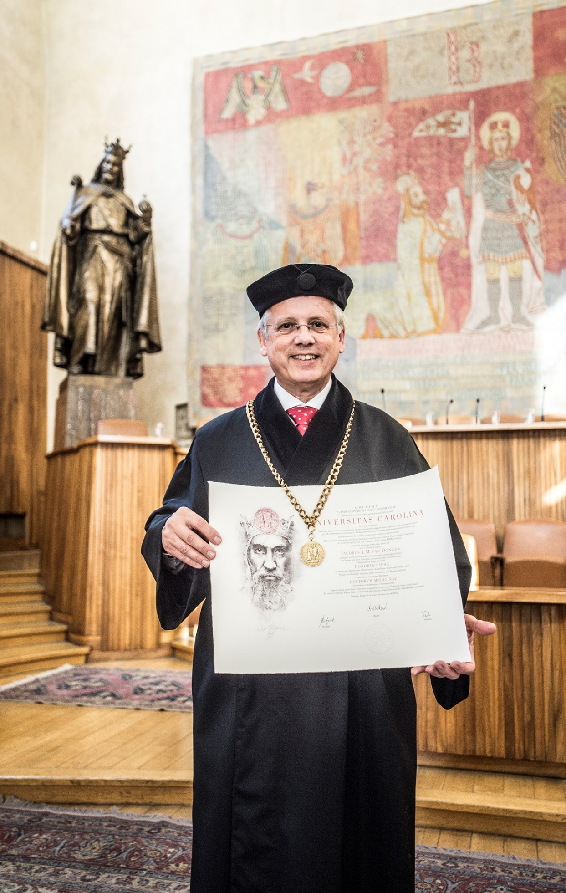
Prof. Jacques J.M. van Dongen, MD, PhD with diploma and golden Charles University medal in the Carolinum before the statue of Charles IV, the founder of Charles University in 1348.
Photos by: © Vladimír Šigut (official photographer of Charles University).

